# Cellular Automaton

A cellular automaton is a grid-based system in which each cell has a state which evolves over time. This is governed by a set of rules, usually dependent on the states of a cells’ neighbours. Each timestep a cells’ state is altered based on these rules. 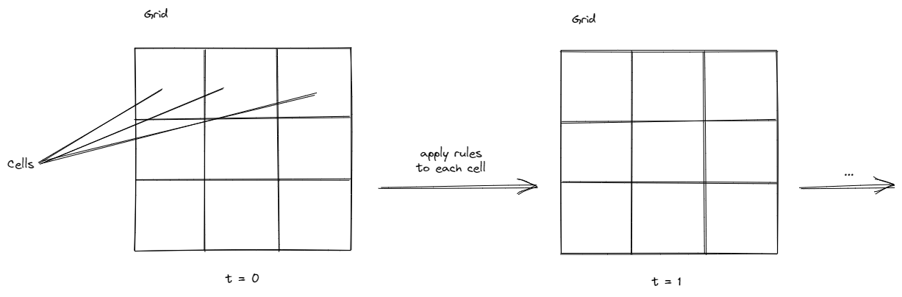

The most well-known example of a cellular automaton is Conways Game of Life. In it, each cell has only two possible states: Living or dead. Conway defined the following rules for the cells and each of its 8 neighbours:

1. A live cell with less than 2 live neighbours will die (underpopulation)
2. A live cell with two or three live neighbours will stay alive
3. A live cell with more than three live neighbours will die (overpopulation)
4. A dead cell with three neighbours will become live (reproduction)

<Conway pen>

Using these simple rules and only two states, the game of life can display an great level of complexity. The initial states of the grid determine how the automaton will evolve. There has been a great amount of research and time spent finding different initial patterns that create interesting behaviour.

# Cyclic Cellular Automaton

A cyclical cellular automaton is a special type of cellular automaton in which each cell increases its state when at least one neighbour has a state exactly one higher than itself. If a cell reaches the highest possible state, it will cycle back to state 0, thus giving this automaton its name. Running this on a two-dimensional grid with random initial sates, we eventually end up with these pulsating spirals:

<https://en.wikipedia.org/wiki/File:Cyclic16V_for_1300_Generations.gif>

The reason this looks like moving particles is because when a cell is in state k, and a neighbouring cell is in state k+1, the former cell will be in state k+1 in the next step. It’s therefore consumed/infected by its neighbour, giving the impressions that the neighbouring cell moved.

Another variation of cyclic cellular automata changes the rule so that for a cell to increase its state, a certain number of neighbouring cells need to be in state k + 1.

These automatons have been studied and their behaviour thoroughly analysed. It’s fascinating how automatons with a small number of states and relatively simple rules can already create quite complex behaviours that take much longer to understand than it takes to define these rules. It’s not difficult to imagine that more complex rules may also offer far more complex behaviour. There are already several implementations to randomize these rules hoping to find novel interesting patterns by chance.

In my implementation I have altered the rules a little bit. There are 4 different automatons or species running in parallel. Each species has number of states n and a threshold value t (0..1).

Instead of checking whether a cell with state k has a neighboring cell with state k+1, I’m simply checking whether the neighbouring cells state is larger than k. Let’s define a neighbour that meets this condition as nt.

I have further defined three conditions for each cell c that are evaluated at each timestep:

1. Is the ratio of nt neighbours larger than t?
2. Is rule 1 false and the number of nt neighbours equal zero?
3. Are Rule 1 and Rule 2 false.

I basically chose these rules through trial and error. They seem to give a greater likelihood of producing behaviour that fills the grid, probably because it increases the likeliness of rule 1 to be met. A lot of the results form structures that remind of ruins or buildings seen from above. And some even look like chipsets. 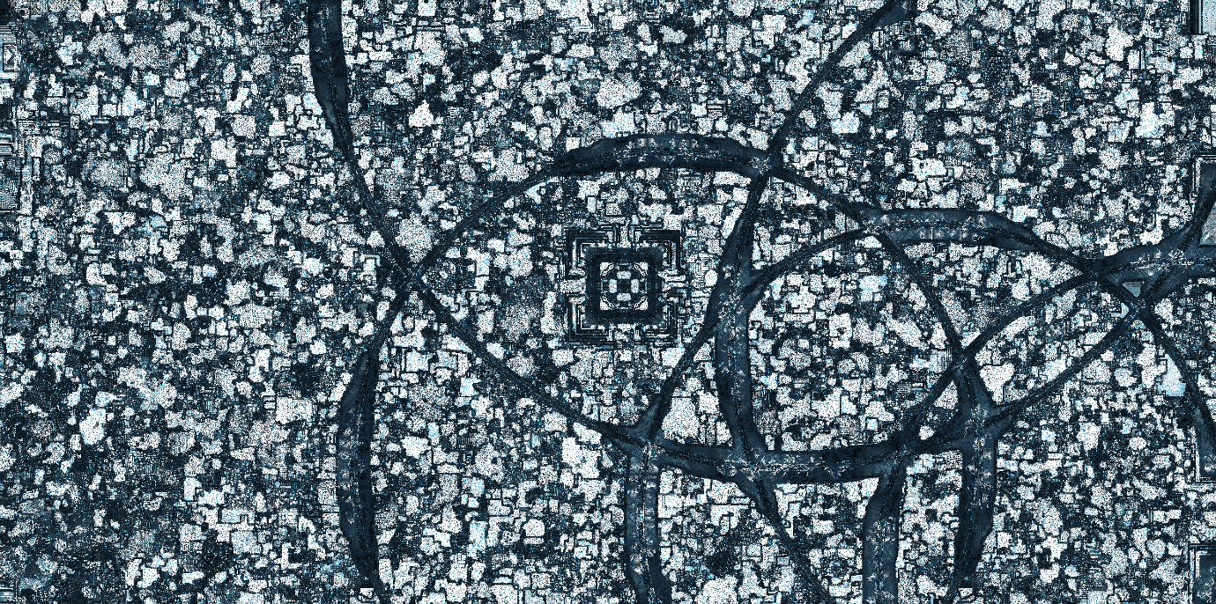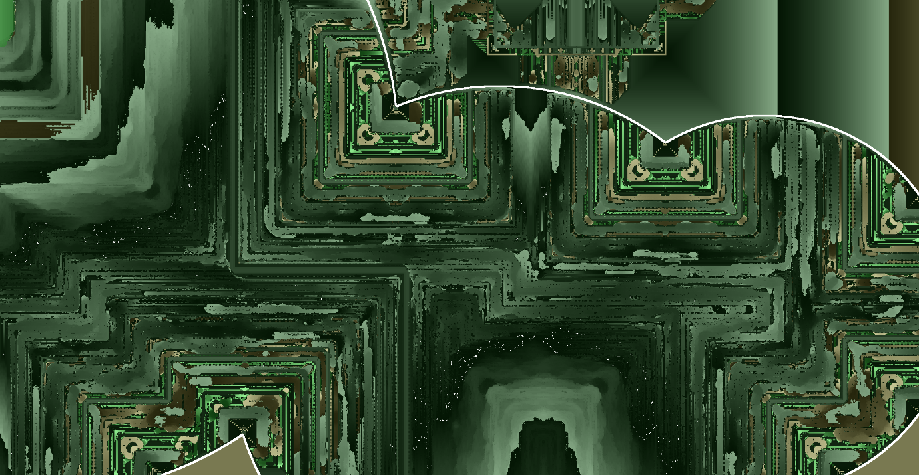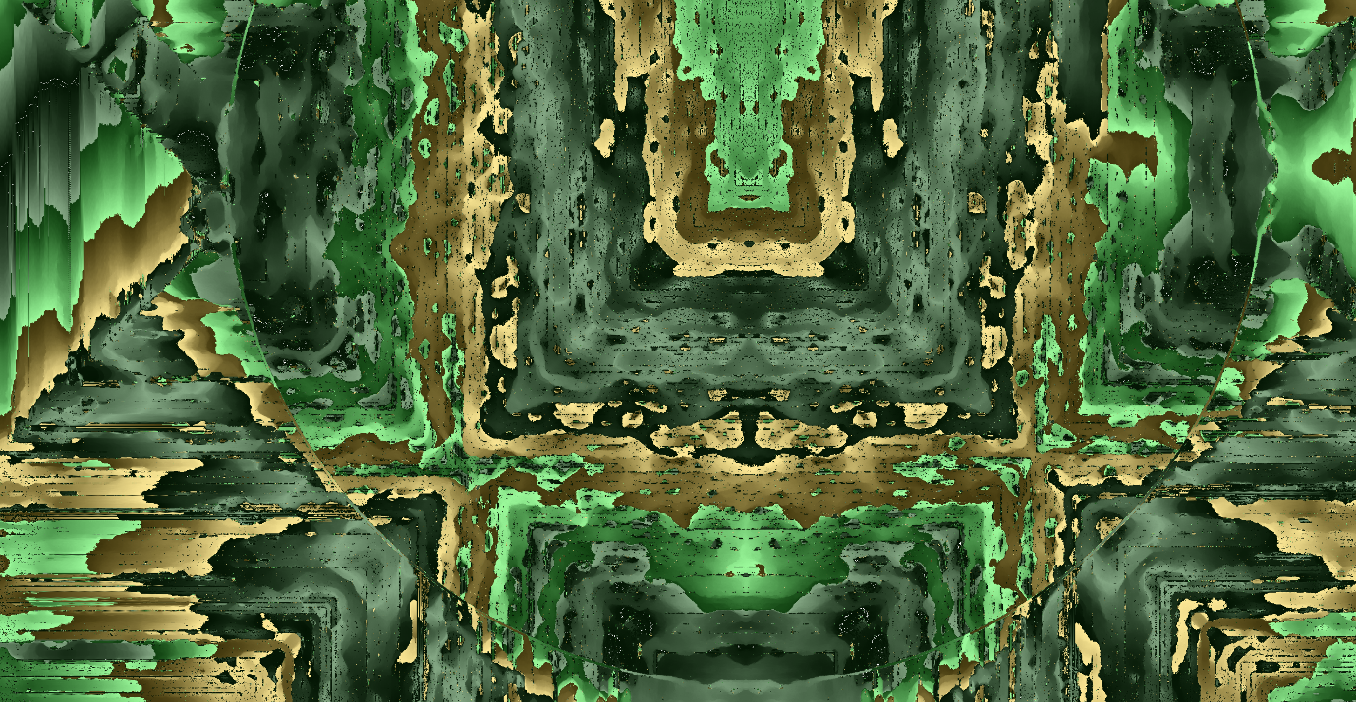

Moreover, I experimented with rules that influence one of the other species. This is similar to

After manually choosing some rules and getting interesting results such as one species amplifying or blocking the other, I increasingly felt like I am trying to set the weights of a neural network by hand. So naturally, I created a system that randomly generates a number of rules that are executed if the conditions are met.

The rules look like this:

VARIABLE + OPERATION + VALUE

Where VARIABLE is the state of one of the four species

OPERATION is either adding, subtracting, dividing, multiplying, or setting to zero.

VALUE is either

1,

2,

3,

4,

the state value of one of the species, or

the number of nt neighbors for one of the species.

If we look at these rules, we can see that the automaton should now have a much larger complex space in which they can operate. For now, I’ve implemented the simulation so that a random ruleset is generated on each page load. Clicking the share button will generate a base64 encoded copy of the ruleset and copy it into your clipboard as well as output it in your browsers’ console.

In the future I might try to create a system for finding interesting rulesets in which the different rules are defined as genes and the ruleset is continuously improved through mutation and combination of the most visually pleasing results..

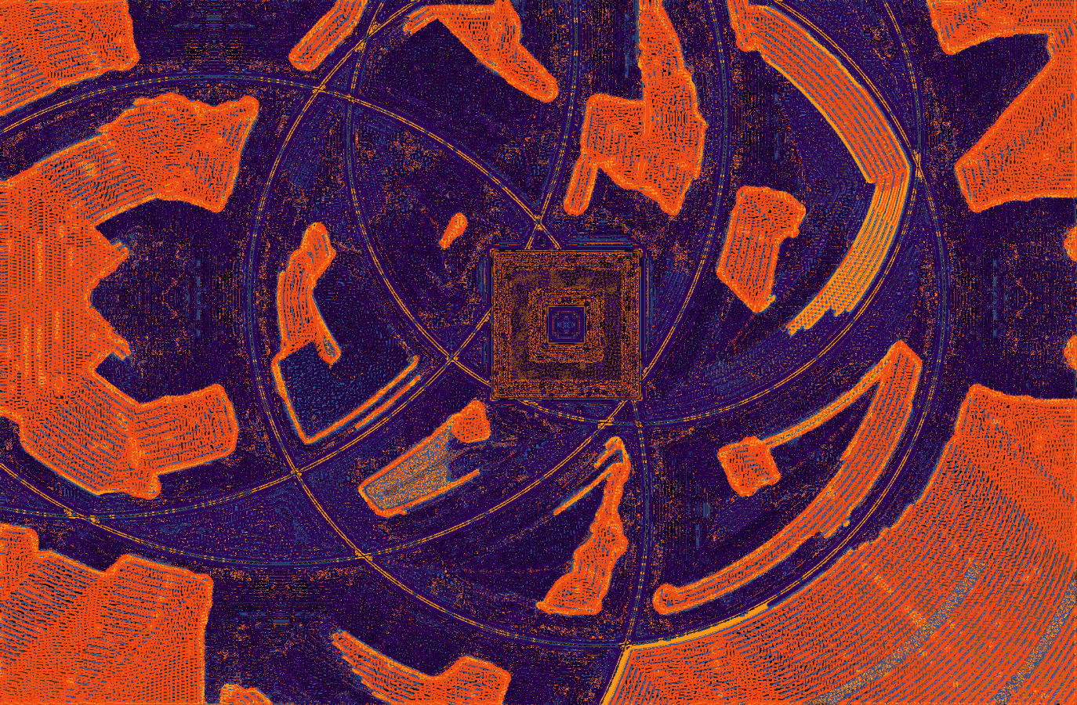

Another part of the effect is created by using a starting pattern with stroked rectangle and circles. These lines often act as barriers between different emerging patterns giving them a more organic look.